1. **INTRODUCTION**

Solar energy harnessing is a challenging process due to the lack of development in the existing technology. Present day technologies are having low conversion efficiency and cost of the technology is also very high. It is our responsibility to develop better technology with cost effectiveness to meet the energy needs of rural Indian villages where there is no accessibility to electric power. The rural Indian population will develop only when there is a accessible power. Solar energy is a major energy source due to its abundant availability in the subcontinent region.

1. **SOLAR PV**

Generating electricity from sunlight was found to be very expensive in the past decade. Due to very high electricity demand, the Government of India is encouraging the use of renewable energy resources such as solar to solve the power crisis and to make the environment greener and sustainable. Currently, the prices of power generation from solar are falling down due to technological advances in solar panels. In this regard, the central government is providing subsidies, tax savings to organizations/institutions/ households for adopting solar energy.

Mokhtari 2009, investigated the position of solar panel to ensure maximum sunlight and thus improving the overall efficiency of the photovoltaic generation system. An Induction motor was controlled using direct flux and torque control technique to optimize the location of the panel when the sun moves on its trajectory. Oltu 2007, and Dousoky 2011, identified that suitable orientation of solar panel using automatic solar trackers helps to improve the panel efficiency.

Gaddy, 2003 introduced photovoltaic panels generated electricity to produce propulsion. The power from solar was used in the components of vehicles such as to charge battery, a computer, inverters and electric traction motors. This minimizes the fuel consumption and its associated emissions, and can save significant cost of gasoline per Watt of photovoltaic power.

Rahman 2010, studied about enhancing the performance of PV solar home system with less investment. This is essential for rural homes where there is a shortage of grid power or the high cost involved for transmission and distribution systems. One of the major limitations of the solar home system is its extremely poor efficiency. Lot of research is going on to improve the performance of the solar, Solar Energy - a Road Map to Success for Rural Development 141 panels. Sun tracking is a method frequently adopted for performance enhancement. However sun tracking devices need expensive control and drive equipments and the power for these equipments has to be provided by the solar panel and the battery installed within the solar home system. Due to high cost and frequent maintenance requirement, such tracking systems are not popular. Even a slight enhancement of the performance of solar cells will drastically reduce the overall per unit energy cost of the solar home system. In this work, authors studied the performance of solar panels by direct reflection of sunlight experimentally. Encouraging results were obtained by fixing plane mirrors at the East-West ends of the panel edge when the panel is inclined at 23.5° with the horizontal.

Dai Qinghui 2009, conducted studies and performed survey and analysis to enhance the efficiency of solar power from PV panels. Their analysis showed that to improve the efficiency of solar power, study of technical aspects of the conversion efficiency of solar panels is necessary. This can be achieved through the solar energy application of automatic tracking system device. Also, the solar power control adopts maximum power point tracking technology and is suitable for storage battery charging and discharging functions. In addition, the application of complex mechanism of photosynthesis, and the “condenser”, which can strengthen the solar energy, will be a future research direction to improve the efficiency of solar power.

Ralph 1996 described solar panel designs that utilize new high-efficiency solar cells and lightweight rigid panel technologies. The resulting designs increase the specific power (W/kg) achievable in the near-term and are well suited to meet the demands of high performance small satellites (smallsats). Advanced solar panel designs have been developed and demonstrated on two NASA contracts.

Yaow-Ming 2005 presented the calculation of the optimum installation angle for fixed solarcell panels based on genetic algorithm (GA) and simulated-annealing (SA) methods. Their investigation reveals that the output power of the solar-cell panel is highly affected by the sunlight incident angle and its efficiency can be improved if the solar-cell panel is properly installed with the optimum angle. The relationship between the sunlight incident angle and the sunlight radiation intensity on the solar-cell panel surface is also presented in this research work.

Xiao Tang 2010, carried out research using a micro heat pipe array in solar panels for monitoring and controlling the effect of temperature on photovoltaic panels. Their research reveals that temperature can be controlled significantly to improve the efficiency of solar panels for certain operating conditions.

1. **SOLAR TRACKING SYSTEM**
   1. **Introduction:**
2. **Purpose:**

A typical solar panel converts only 30 to 40 percent of the incident solar irradiation into electrical energy. Thus to get a constant output, an automated system is required which should be capable to constantly rotate the solar panel. The Sun Tracking System (STS) was made as a prototype to solve the problem, mentioned above. It is completely automatic and keeps the panel in front of sun until that is visible. The unique feature of this system is that instead of taking the earth as its reference, it takes the sun as a guiding source. Its active sensors constantly monitor the sunlight and rotate the panel towards the direction where the intensity of sunlight is maximum. With the rapid increase in population and economic development, the problems of the energy crisis and global warming effects are today a cause for increasing concern. The utilization of renewable OPEN ACCESS Sensors 2013,13 3158 energy resources is the key solution to these problems. Solar energy is one of the primary sources of clean, abundant and inexhaustible energy that not only provides alternative energy resources, but also improves environmental pollution. The most immediate and technologically attractive use of solar energy is through photovoltaic conversion. The physics of the PV cell (also called solar cell) is very similar to the classical p-n junction diode. The PV cell converts the sunlight directly into direct current (DC) electricity by the photovoltaic effect.

1. **Scope:**

* It can be used for small and medium scale power generations.
* It can be used for power generation at remote places where power lines are not accessible.
* It can be used for domestic and industrial power backup system.
* Solar radiation Tracker has played a vital role in increasing the efficiency of solar panels in recent years, thus proving to be a better technological achievement. The vital importance of a dual axis solar tracker lies in its better efficiency and sustainability to give a better output compared to a fived solar panel or a single axis solar tracker. The tracking system is designed such that it can trap the solar energy in all possible directions.

1. **Definition:**

A Solar tracker is an automated solar panel which actually follows the sun to get maximum power. The primary benefit of a tracking system is to collect solar energy for the longest period of the day, and with the most accurate alignment as the Sun’s position shifts with the seasons. Dual Axis Tracker has two different degrees through which they use as axis of rotation. The dual axis are usually at a normal of each rotate both east to west (zenithal) and north to south. Solar tracking is the most appropriate technology to enhance the electricity production of a PV system. To achieve a high degree of tracking accuracy, several approaches have been widely investigated. Generally, they can be classified as either open-loop tracking types based on solar movement mathematical models or closed-loop tracking types using sensor-based feedback controllers. In the open-loop tracking approach, a tracking formula or control algorithm is used. Referring to the literature, the azimuth and the elevation angles of the Sun were determined by solar movement models or algorithms at the given date, time and geographical information. The control algorithms were executed in a microprocessor controller. In the closed-loop tracking approach, various active sensor devices, such as charge couple devices (CCDs) or light dependent resistors (LDRs) were utilized to sense the Sun’s position and a feedback error signal was then generated to the control system to continuously receive the maximum solar radiation on the PV panel. This paper proposes an empirical research approach on this issue. Solar tracking approaches can be implemented by using single-axis schemes, and dual-axis structures for higher accuracy systems. In general, the single-axis tracker with one degree of freedom follows the Sun’s movement from the east to west during a day while a dual-axis tracker also follows the elevation angle of the Sun. In recent years, there has been a growing volume of research concerned with dual-axis solar tracking systems. However, in the existing research, most of them used two stepper motors or two DC motors to perform dual-axis solar tracking. With two tracking motors designs, two motors were mounted on perpendicular axes, and even aligned them in certain directions.

* 1. **Overall Description:**
     1. **Product Perspective:**

1. **System Interface:**

ATmega328p Microcontroller: The high-performance Microchip Pico Power 8-bit AVR RISC-based microcontroller combines 32KB ISP flash memory with read-while-write capabilities, 1024B EEPROM, 2KB SRAM, 23 general purpose I/O lines, 32 general purpose working registers, three flexible timer/counters with compare modes, internal and external interrupts, serial programmable USART, a byte-oriented 2-wire serial interface, SPI serial port, a 6-channel 10-bit A/D converter (8- channels in TQFP and QFN/MLF packages), programmable watchdog timer with internal oscillator, and five software selectable power saving modes. The device operates between 1.8-5.5 volts.

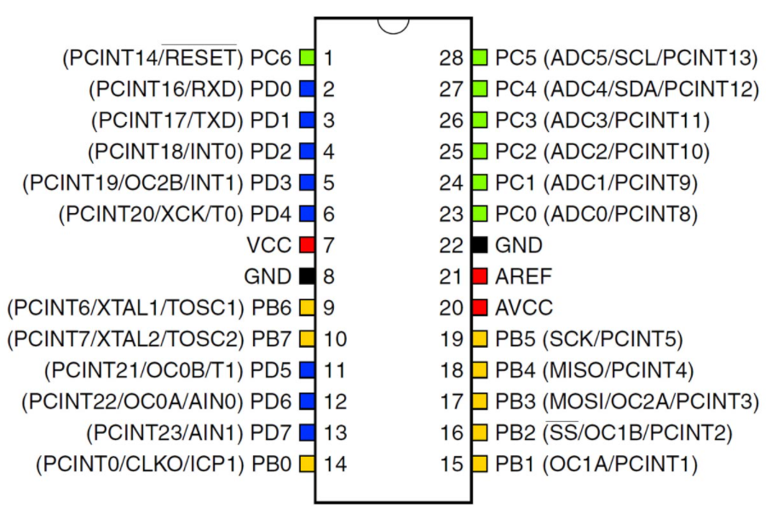

1. **User Interface:**

It should be the connector between the various systems and the system or between other parts or unit of the system.

1. **Hardware Interface:**

**Solar Panel:** Solar panel refers to a panel designed to absorb the sun's rays as a source of energy for generating electricity or heating. Photovoltaic modules use light energy (photons) from the Sun to generate electricity through the photovoltaic effect. The majority of modules use wafer-based crystalline silicon cells or thin-film cells. The structural (load carrying) member of a module can either be the top layer or the back layer. Cells must also be protected from mechanical damage and moisture. Most modules are rigid, but semi-flexible ones are available, based on thin-film cells. The cells must be connected electrically in series, one to another. Externally, most of photovoltaic modules use MC4 connector’s type to facilitate easy weatherproof connections to the rest of the system. Modules electrical connections are made in series to achieve a desired output voltage and/or in parallel to provide a desired current capability.

**LDRs:** A Light Dependent Resistor (LDR) or a photo resistor is a device whose resistivity is a function of the incident electromagnetic radiation. Hence, they are light sensitive devices. They are also called as photo conductors, photo conductive cells or simply photocells. They are made up of semiconductor materials having high resistance. A photo resistor is made of a high resistance semiconductor. In the dark, a photo resistor can have a resistance as high as several mega ohms (MΩ), while in the light, a photo resistor can have a resistance as low as a few hundred ohms. If incident light on a photo resistor exceeds a certain frequency, photons absorbed by the semiconductor give bound electrons enough energy to jump into the conduction band. The resulting free electrons (and their hole partners) conduct electricity, thereby lowering resistance.

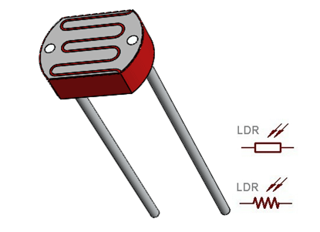

**Servo Motors:** A servomotor is a rotary actuator or linear actuator that allows for precise control of angular or linear position, velocity and acceleration. It consists of a suitable motor coupled to a sensor for position feedback. It also requires a relatively sophisticated controller, often a dedicated module designed specifically for use with servomotors. Servomotors are not a specific class of motor although the term servomotor is often used to refer to a motor suitable for use in a closed-loop control system. A servomotor is a closed-loop servomechanism that uses position feedback to control its motion and final position. The input to its control is a signal (either analogue or digital) representing the position commanded for the output shaft. The motor is paired with some type of encoder to provide position and speed feedback. In the simplest case, only the position is measured. The measured position of the output is compared to the command position, the external input to the controller. If the output position differs from that required, an error signal is generated which then causes the motor to rotate in either direction, as needed to bring the output shaft to the appropriate position. As the positions approach, the error signal reduces to zero and the motor stops.The very simplest servomotors use position-only sensing via a potentiometer and bang-bang control of their motor; the motor always rotates at full speed (or is stopped). This type of servomotor is not widely used in industrial motion control, but it forms the basis of the simple and cheap servos used for radio-controlled models. More sophisticated servomotors use optical rotary encoders to measure the speed of the output shaft and a variable-speed drive to control the motor speed. Both of these enhancements, usually in combination with a PID control algorithm, allow the servomotor to be brought to its commanded position more quickly and more precisely, with less overshooting.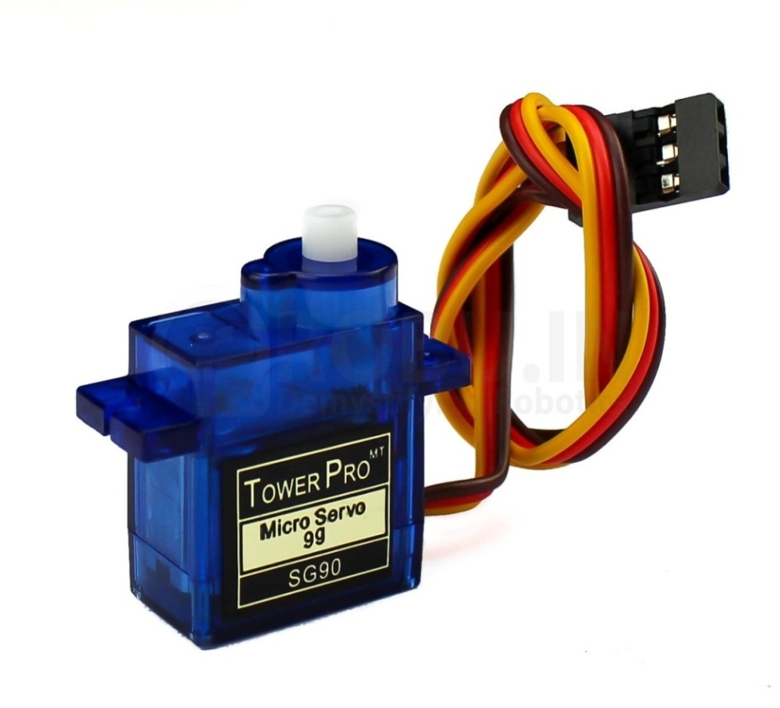

1. **Software Interface:** Arduino IDE:-A program for Arduino may be written in any programming language for a compiler that produces binary machine code for the target processor. Atmel provides a development environment for their microcontrollers, AVR Studio and the newer Atmel Studio. The Arduino project provides the Arduino integrated development environment (IDE), which is a cross-platform application written in the programming language Java. It originated from the IDE for the languages Processing and Wiring. It includes a code editor with features such as text cutting and pasting, searching and replacing text, automatic indenting, brace matching, and syntax highlighting, and provides simple one-click mechanisms to compile and upload programs to an Arduino board. It also contains a message area, a text console, a toolbar with buttons for common functions and a hierarchy of operation menus. A program written with the IDE for Arduino is called a sketch. Sketches are saved on the development computer as text files with the file extension.ino. Arduino Software (IDE) pre1.0 saved sketches with the extension.pde. The Arduino IDE supports the languages C and C++ using special rules of code structuring. The Arduino IDE supplies a software library from the Wiring project, which provides many common input and output procedures. User-written code only requires two basic functions, for starting the sketch and the main program loop, that are compiled and linked with a program stub main() into an executable cyclic executive program with the GNU tool chain, also included with the IDE distribution. The Arduino IDE employs the program to convert the executable code into a text file in hexadecimal encoding that is loaded into the Arduino board by a loader program in the board's firmware.
2. **Operation:**

1. LDRs are used as the main light sensors. Two servo motors are fixed to the structure that holds the solar panel. The program for Arduino is uploaded to the microcontroller. The working of the project is as follows.

2. LDRs sense the amount of sunlight falling on them. Four LDRs are divided into top, bottom, left and right.

3. For east – west tracking, the analog values from two top LDRs and two bottom LDRs are compared and if the top sets of LDRs receive more light, the vertical servo will move in that direction.

4. If the bottom LDRs receives more light, the servo moves in that direction.

5. For angular deflection of the solar panel, the analog values from two left LDRs and two right LDRs are compared. If the left set of LDRs receives more light than the right set, the horizontal servo will move in that direction.

6. If the right set of LDRs receives more light, the servo moves in that direction.

1. **BLOCK DIAGRAM OF SYSTEM**

In the given block diagram we have seen that when the sunlight is falling on solar tracker module then this energy is converted into electrical energy and this energy is stored in the energy storing devices and after according to the requirements we can covert the energy form by inverter and converter and used in variable load such as irrigation, electrical fences, pedestal lightning, rural electrification etc.

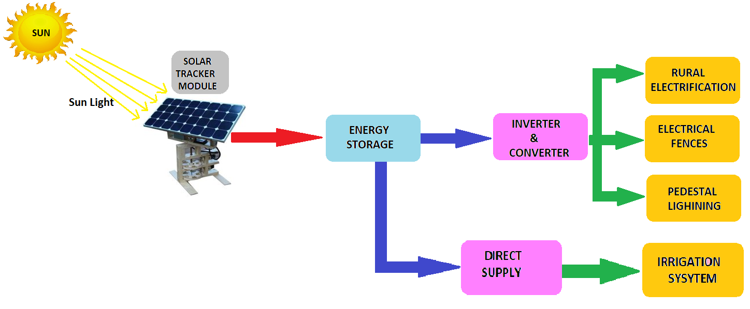

1. **CIRCUIT DIAGRAM OF SYSTEM**

In this, we are going to use some light sensor LDR to track the sunlight direct the solar panel towards the area their Sun moves. As we increases the light intensity on LDR the signal is send to the arduino and hence it's guide the servo motor to better place the solar panel and increases it efficiency.

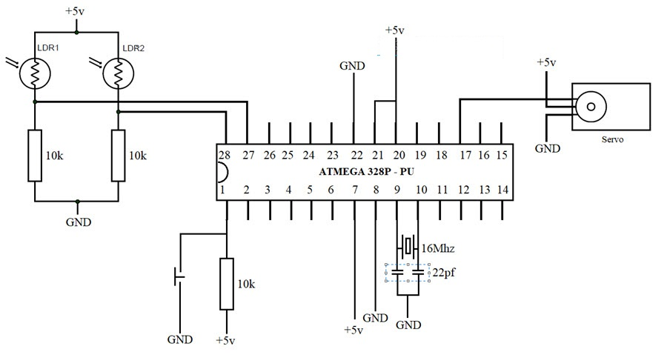

1. **DVANTAGES OF SYSTEM**

* It protect against power interruption.
* Reduces the water usage.
* It brings new economic opportunities.
* In rural areas around the world, however, access to electricity is sparse and expensive.
* The use of solar power in rural areas is a cheaper, cleaner alternative.
* One significant benefit of solar power in rural areas is increased availability.
* Rural areas lack this resource because their countries’ electric grids stop before reaching them.
* Major benefit is this system is pollution-free.
* The advantages of solar power in rural areas illustrate that the development of better solar technology is beneficial for areas that otherwise would not be able to access electricity.

1. **DISADVANTAGES OF SYSTEM**

* Solar doesn’t work at night.
* The biggest disadvantage of solar energy is that it’s not constant. So energy must be stored or sourced elsewhere at night.
* over winter months when there are less sunlight hours and sun radiation is less intense.
* Solar electricity storage technology has not reached its potential.
* Many solar drip feed batteries available, these are currently costly and bulky, and more appropriate to small scale home solar panels than large solar farms.
* The downfall is that thin-film is currently less efficient than crystalline wafer solar.

1. **FUTURE SCOPE**

* Since majority of the population live in rural areas, there is much scope for solar cases ecosystem being promoted in these areas. Use of solar energy can reduce the use of firewood and dung cakes by rural household.
* Solar will be seen more as a viable energy source, not just as an alternative to other renewable sources but also to a significant proportion of conventional grid power.
* The testing and refinement of off-grid and rooftop solar models in the seed phase will help lead to the explosive growth of this segment in the growth phase.
* Global prices for photovoltaic (PV) modules are dropping, reducing the overall cost of generating solar power.
* According to one estimates, the combination of electricity demand growth, fossil fuel cost and availability challenges, and supportive environmental regulations could increase solar power capacity.

1. **CONCLUSION**

* The invention of solar tracking system helps us improve the performance of PV Solar system in simple way.
* Improved the utilization rate of solar energy and efficiency of photovoltaic power generation system.
* This high efficiency energy used for rural development.
* When used in rural electrification, no need of power through grid system.
* When used in irrigation systems then save the wastage of extra water and electricity.
* Renewal energy help in development of rural area of our locality.
* As per the geographical location of the country, India stands to its benefit and has tremendous scope of generating solar energy. Solar Power Generation alone can cater more than 60-65% of our entire need of power.

**13. REFERENCES**

1. Ivan Jorge Gabe, “Design and Implementation of a low cost dual axis autonomous solar tracker”, 2017, IEEE.
2. Sunil Kamble, Vaibhav Chavan, “Dual Axis Solar Tracker System”, 2015, IJIERT(http://www.irjet.net/)
3. S.P.Maniraj , Tanya Chaudhary , Akanksha Agarwal , Nandini Kishore , Vaibhavi Verma “ Irrigation Management System Using Soil Moisture Sensor and Arduino” Journal of Network Communications and Emerging Technologies (JNCET) Volume 8, Issue 4, April (2018)
4. IEEE guide for Terrestrial Photovoltaic Power System Safety, IEEE Standard 1374-1998
5. Anantha A, and Chowhan P L August 19961, Village electrification using Renewables, paper presented at International workshop on Renewable Energy and Village Electrification,. pp 2181-2186.
6. Faranda, and Moris Gualdoni, Performance analysis of a single-axis tracking PV system, IEEEJournal of Photovoltaic's, vol. 2, no. 4, 2012, pp.524-531.
7. Dumas, M., Ingende, G., Tention, K., and Thompson, M., “Real-Time Intelligent Solar Energy System,” Preliminary Design Review, Mercer University School of Engineering, Macon, GA US December 2013.
8. https://www.optimum-tracker.com/solartracks
9. http://www.researchgate.net
10. Solar Technologies | Photovoltaic Solar Panels | Thin Film Solar Panels | Solar Thermal. (n.d.).Solar Panels, Photovoltaic Systems, Solar Solutions for Home, Business & Utility-Scale-Sun Power. Retrieved August 29, 2013, http://us.sunpowercorp.com/solar-resources/how-solar- works/solar-technologies.
11. "Solar Angle Calculator." Solar Electricity Handbook. N.P., n.d. Web. 25 Sept. 2013. http://solarelectricityhandbook.com/solar-angle-calculator.html.
12. Kumar, Subhash, Design, development and performance test of an automatic two-Axissolar tracker system, India Conference (INDICON), 2011 Annual IEEE., 2011
13. www.electronic4u.com
14. http://www.energymile.com
15. https://www.adtelinc.com
16. http://www.sarjournal.com